PROJECT TITILE
Automated Backup Web Manager

M VARSHITH REDDY SHASHIDHAR
CYBER SECURITY CYBER SECURITY MENTOR
TA1CS1025123 TEKS ACADEMY
TEKS ACADEMY 9603343287
9390542631

1.Abstract:
In the modern digital era, data has become one of the most valuable assets for individuals, organizations, and enterprises. With the increasing dependence on computer systems and digital storage, protecting data from loss, corruption, or accidental deletion has become a critical requirement. Data loss can occur due to several reasons such as hardware failures, system crashes, human errors, malicious attacks, or software malfunctions. Therefore, implementing an efficient and reliable backup system is essential to ensure data safety and system continuity.
The Automated Backup Web Manager is a Linux-based backup management system designed to automate the process of backing up important directories and files. The main objective of this project is to develop a centralized system that allows administrators to schedule automated backups, manage backup files, and monitor backup activities through a simple web interface. By integrating Linux utilities such as Bash scripting, Cron jobs, rsync, and tar, the system efficiently performs backup operations and stores them in compressed archive formats.
The system works by allowing administrators to select directories that need to be backed up. The backup script automatically copies the files using rsync, compresses them using tar, and stores them in a designated backup directory. Cron jobs are used to schedule the backup process at specific time intervals, ensuring that backups are performed regularly without manual intervention. In addition, the system maintains detailed log files that record backup start times, completion times, and any errors that occur during the process.

2. Problem Statement
In today's digital world, organizations and individuals rely heavily on computer systems to store and manage important data. This data may include documents, project files, databases, system configurations, and other critical information. However, data loss can occur due to various reasons such as hardware failures, accidental deletion, malware attacks, software errors, or system crashes. Without a proper backup system, recovering lost data becomes extremely difficult or sometimes impossible.
Many users still rely on manual backup methods, where files are copied and stored periodically by administrators or users. Manual backup processes are time-consuming, inefficient, and prone to human error. Administrators may forget to perform backups regularly, backups may not be properly organized, and there may be no clear record of when the last backup was performed. This creates serious risks for organizations that depend on consistent and reliable data availability.
Another major challenge is the lack of centralized backup management. In many systems, backup files are scattered across multiple locations, making it difficult to monitor backup status, track backup history, or quickly restore data when required. Without proper logging and monitoring, administrators cannot easily verify whether backups were completed successfully or if errors occurred during the process.

3. Project Objectives
The main objectives of the Automated Backup Web Manager are:
- To automate the process of backing up important directories in a Linux environment.
- To compress backup data into archive files to save storage space.
- To schedule automated backups using Cron jobs.
- To maintain logs for monitoring backup activities.
- To provide a web-based interface for viewing logs and downloading backups.
- To create a reliable and efficient backup management system for system administrators.
By achieving these objectives, the project aims to improve system reliability and reduce the risk of data loss.

4. Project Scope
The Automated Backup Web Manager is designed to provide a simple and efficient solution for managing file backups in a Linux environment. The system focuses on automating the backup process, reducing manual effort, and ensuring that important data is safely stored and easily accessible when needed. The project mainly targets system administrators and small organizations that require a reliable backup management system without complex configuration.
The scope of this project includes the development and implementation of a backup automation system that integrates Linux utilities with a web-based interface for monitoring and managing backups.
Key Scope Areas
• Automated Directory Backup
The system allows administrators to select specific directories that need to be backed up. The backup script automatically copies the selected files and folders into a dedicated backup directory.
• Backup Compression and Storage
All backup files are compressed into archive formats such as .tar.gz. This reduces storage space and allows administrators to manage multiple backups efficiently.
• Backup Scheduling
The project supports automated scheduling of backup tasks using cron jobs, allowing backups to run at specific times such as daily, weekly, or hourly.
• Backup Log Monitoring
The system records backup activities in a log file. Administrators can view these logs to verify whether backups were completed successfully or if any errors occurred during the process.
• Web-Based Backup Management
A simple web interface allows administrators to access backup files, monitor logs, and manage backups without using command-line tools.
• Backup Download Feature
Users can download backup archives directly from the web interface, making it easier to store backups in external locations or restore data when necessary.
• Local Server Implementation
The project is implemented on a local Linux server environment using Apache, making it suitable for internal organizational use or system administration purposes.
• Efficient File Synchronization
The system uses the rsync utility, which ensures that only changed files are copied during backups, improving performance and reducing system load.

5. Tools and Technologies Used
The development of this project involves several tools and technologies that enable automation, data management, and web interaction.
Linux Operating System
The Linux operating system is used as the primary platform for developing and running the Automated Backup Web Manager. Linux provides a stable, secure, and powerful environment for managing files, executing scripts, and hosting web applications. It also offers built-in utilities such as cron, rsync, and tar that are essential for implementing automated backup systems. Because of its reliability and command-line capabilities, Linux is widely used in server environments and makes it ideal for managing data backups efficiently.
Bash Scripting
Bash scripting is used to automate the backup process in the project. Bash allows multiple commands to be executed sequentially in a script file, which makes it possible to automate tasks such as copying files, compressing directories, and writing logs. In this project, a script named backup.sh performs the main backup operations, including selecting directories, transferring files, creating compressed backup archives, and recording backup activity. This automation eliminates the need for manual backups and ensures consistent backup operations.
Cron Jobs
Cron is a time-based task scheduler available in Linux systems that allows commands or scripts to run automatically at scheduled times. In this project, cron jobs are used to schedule the execution of the backup script at regular intervals, such as every hour or every day. By using cron scheduling, the system can perform backups automatically without requiring administrator intervention. This ensures that important data is backed up regularly and reduces the risk of human error in the backup process.
Rsync
Rsync is a fast and efficient file synchronization and transfer tool commonly used for backup operations. It is designed to copy files and directories while minimizing data transfer by only updating the parts of files that have changed. In this project, rsync is used to copy selected directories from the source location to the backup directory. It preserves file permissions, timestamps, and directory structures, ensuring that the backup data remains accurate and consistent.

Tar Utility
The tar utility is used for archiving and compressing backup files into a single compressed file format. After the files are copied using rsync, the tar command combines them into a compressed archive such as .tar.gz, which reduces storage space and makes backup files easier to manage and transfer. In this project, tar creates timestamped backup archives so that multiple backups can be stored and identified easily for future restoration.
PHP
PHP is a server-side scripting language used to develop the web interface for the backup management system. PHP allows the application to interact with server files and dynamically display information through a web browser. In this project, PHP scripts are used to display available backup files, show backup logs, and allow users to download backup archives. This makes it possible for administrators to manage backups through a simple graphical interface instead of relying only on command-line operations.
Apache Web Server
Apache is used as the web server to host the Automated Backup Web Manager application. It processes incoming browser requests and serves the PHP web pages that form the system interface. The project files are stored inside the Apache web root directory, allowing the application to be accessed through a web browser using a local server address. Apache ensures that the web interface is available and functions correctly within the Linux environment.

6. Deliverables
The project deliverables include all components required to implement and operate the backup system.
1. Backup Automation Script
A Bash script (backup.sh) that performs directory backups and compression.
2. Web Interface
A PHP-based interface that allows users to:
- View backup files
- Download backup archives
- Monitor backup logs
3. Backup Storage Directory
A folder that stores compressed backup files generated by the system.
4. Log Management System
A logging mechanism that records backup operations, errors, and completion status.
5. Project Documentation
Detailed documentation describing the system architecture, implementation, and functionality.

7. Project Implementation
The implementation of the Automated Backup Web Manager involves multiple steps including environment setup, script development, backup automation, and web interface integration.

Step 1: Project Setup
The project directory was created inside the Apache web server directory:
/var/www/html/backup-manager/
The project structure includes scripts, backups, logs, and web interface files.
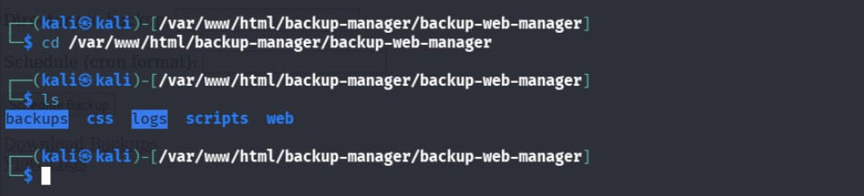
Step 2: Backup Script Development
A Bash script named backup.sh was created to automate the backup process.
The script performs the following operations:
- Accepts a directory path as input.
- Uses rsync to copy files to the backup directory.
- Compresses the backup using tar.
- Records backup activity in a log file.
Example command:
./backup.sh /home/kali/Documents
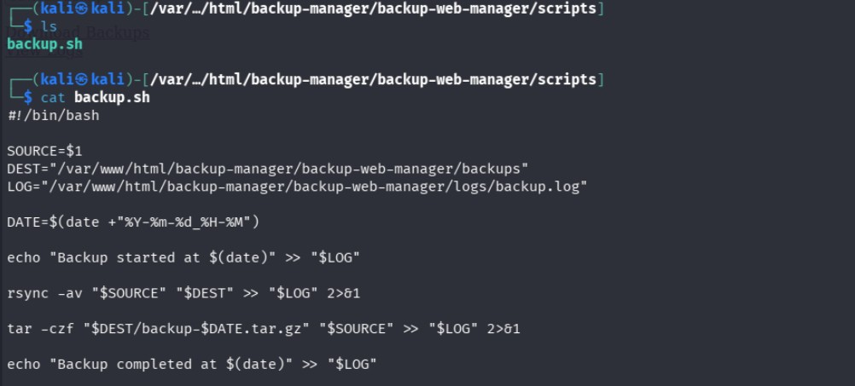

Step 3: Automated Backup Scheduling
Cron jobs were configured to run the backup script automatically at regular intervals.
Example cron configuration:
*/10 * * * * /var/www/html/backup-manager/scripts/backup.sh /home/kali/Documents
This ensures backups are performed automatically without manual intervention.

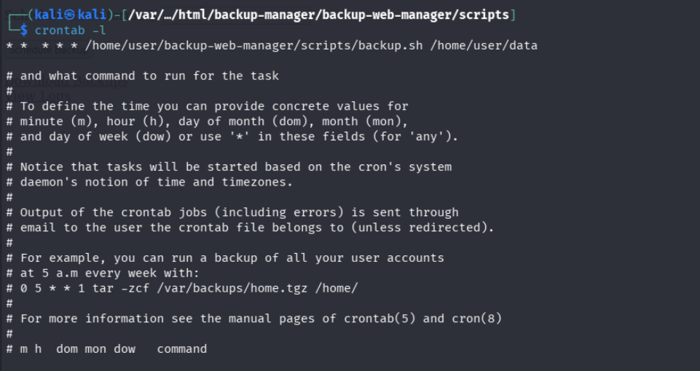

Step 4: Log Management
The backup script writes log information into a log file:
logs/backup.log
The log records:
- Backup start time
- Backup completion time
- Errors during backup operations
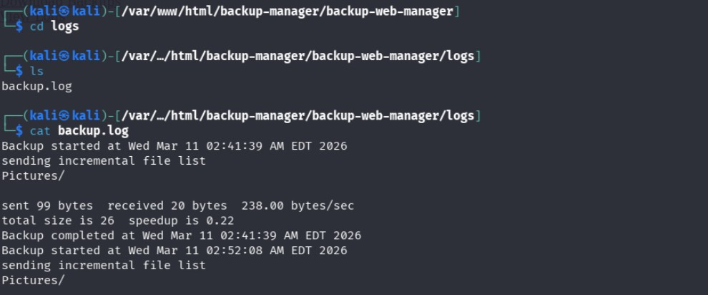

Step 5: Web Interface Implementation
A simple PHP-based web interface was developed to interact with the backup system.
Main pages include:
index.php
- Displays a list of available backup files.
download.php
- Allows users to download backup archives.
logs.php
- Displays backup log records.
The web interface is accessed using:
http://127.0.0.1/backup-manager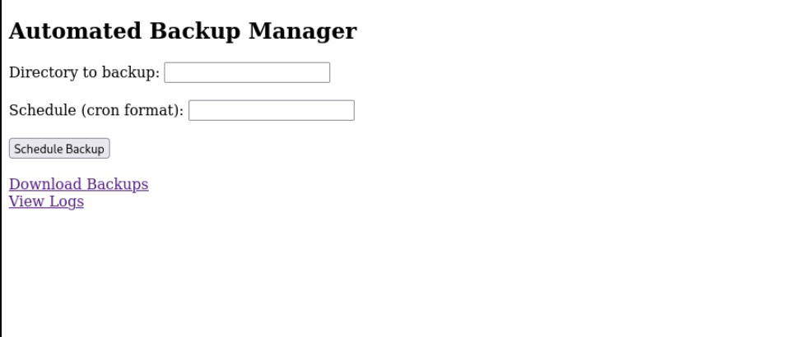

8. Conclusion

The Automated Backup Web Manager successfully demonstrates the implementation of a Linux-based automated backup system integrated with a web interface for monitoring and management. By combining Bash scripting, Cron job scheduling, and PHP-based web technologies, the system provides an efficient solution for managing backups in a centralized manner.
The project simplifies backup management by automating repetitive tasks and providing an easy-to-use interface for administrators. This reduces the risk of data loss and improves system reliability.
Future improvements may include adding features such as:
- Cloud backup integration
- Backup encryption
- User authentication for secure access
- Email notifications for backup status
Overall, the project highlights the effectiveness of Linux automation tools and web technologies in building reliable data management systems.

